Test # 284
Instrument Name Consistometer
Instrument Type Consistometer
Test Start 25/04/01 10:00
Test Stop 3:57:53
Well ID # Pad1/2-5652
Customer KOGALYM
Cement Class G
Additives 12%MS+1.2%TDF-1+SodaAsh+Defoamer
Cement Mfr DYKERHOFF
BHCT 65
BHST 85
Density 1400
Fluid Loss 96cc/30min
Job Type 146 MM CSG
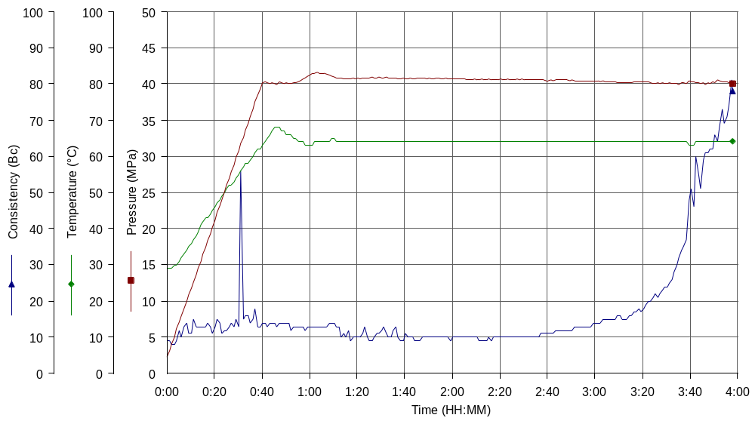
Comments MPa:40(40min); T:65(40min), Kogalym cement, tap water, dry blend Cem+MS, prermix TDF, H=2900 m

